**EC2 TASKS**

1. Launch one ec2 using Amazon Linux 2 image and add script in user data to install Apache.

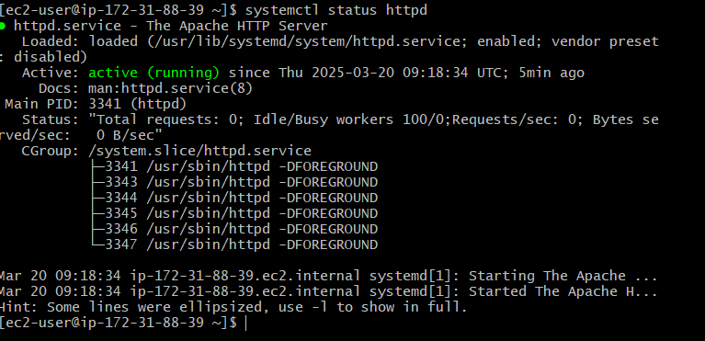

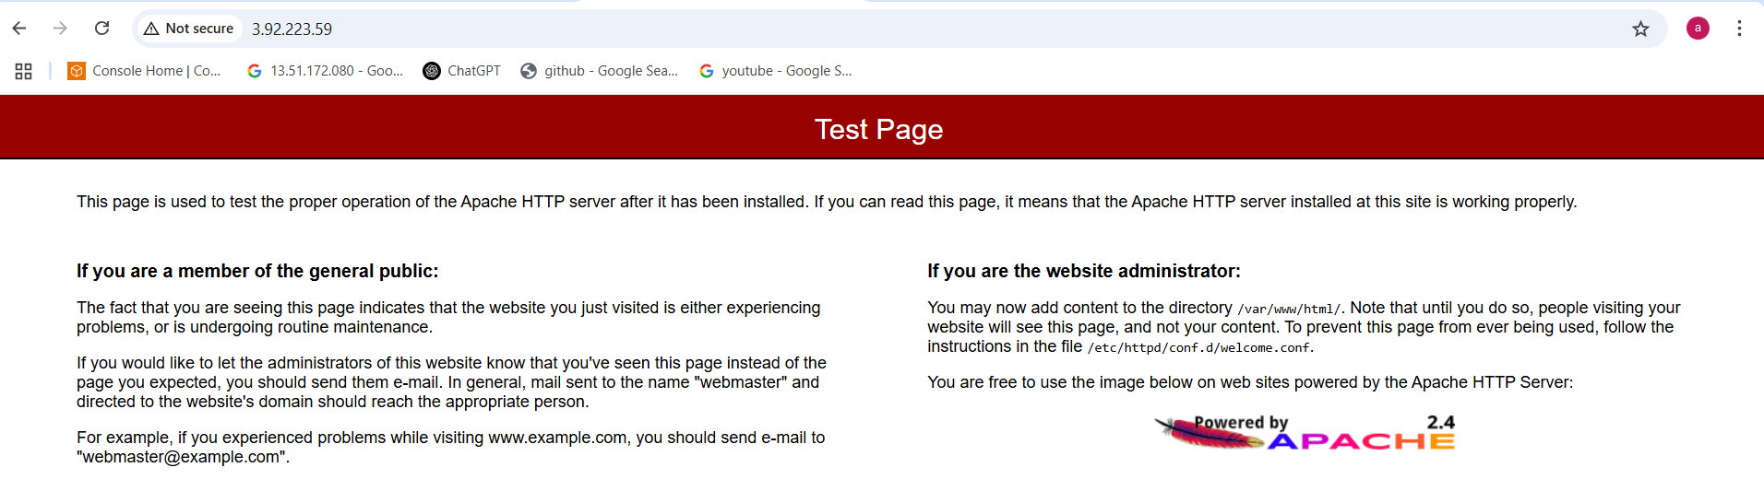

1. Launch one ec2 using Ubuntu image and add script in user data to install Nginx.

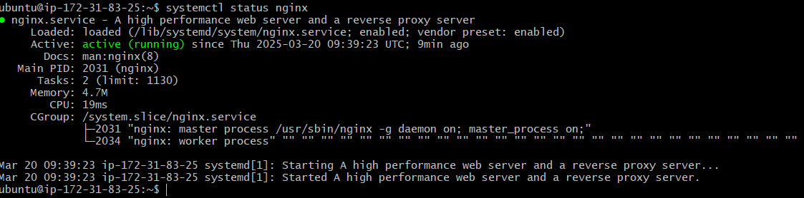

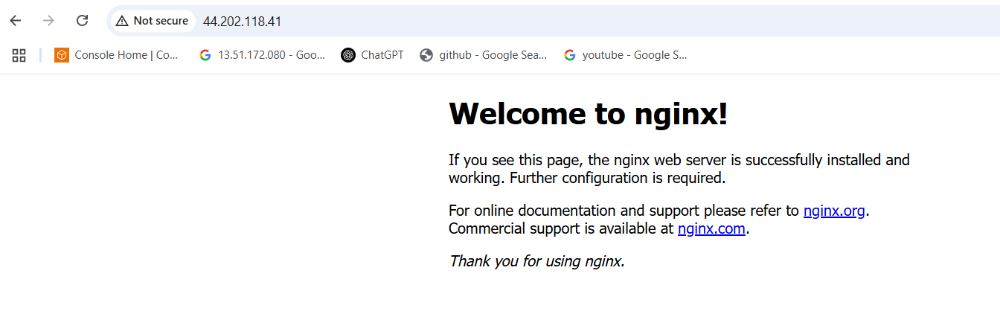

1. Launch one windows server and install tomcat in windows.

Step:1 create ec2 instance with windows AMI

Step:2 select “RDP client” then download remote desktop file

Step:3 now click on “get password” upload the pemkey then decrept password like this

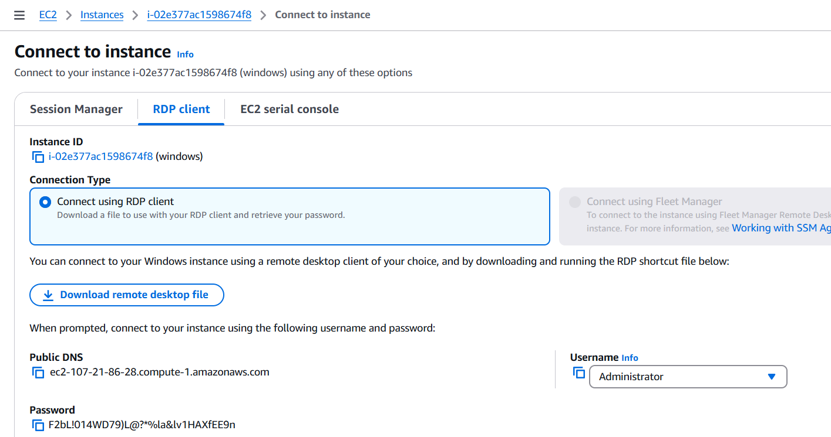

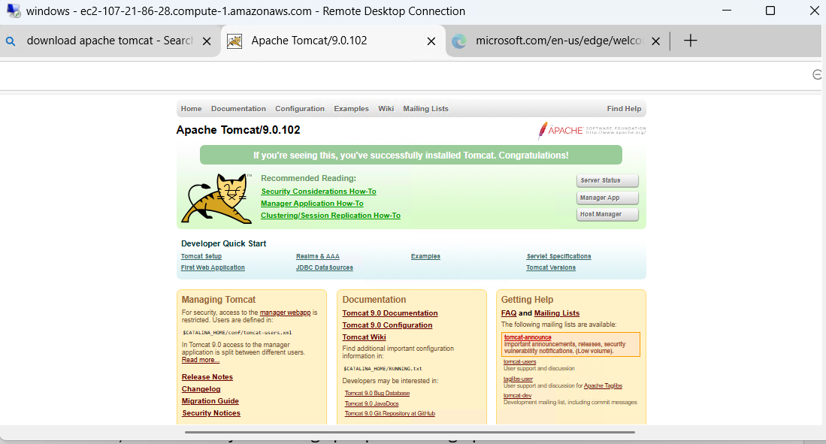

1. Take snapshot of the instane created in Task 1.

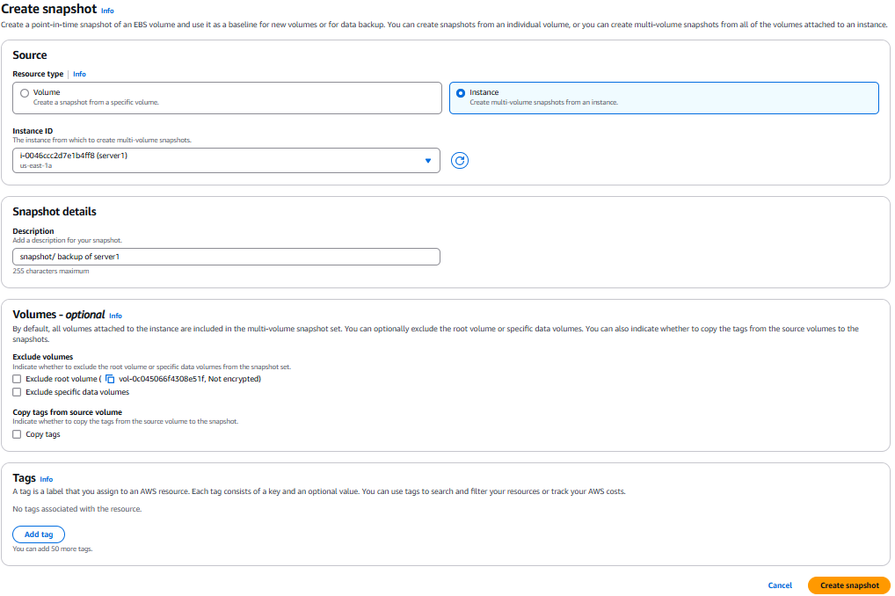

1. Assign password less authentication for ec2 created on Task 2.

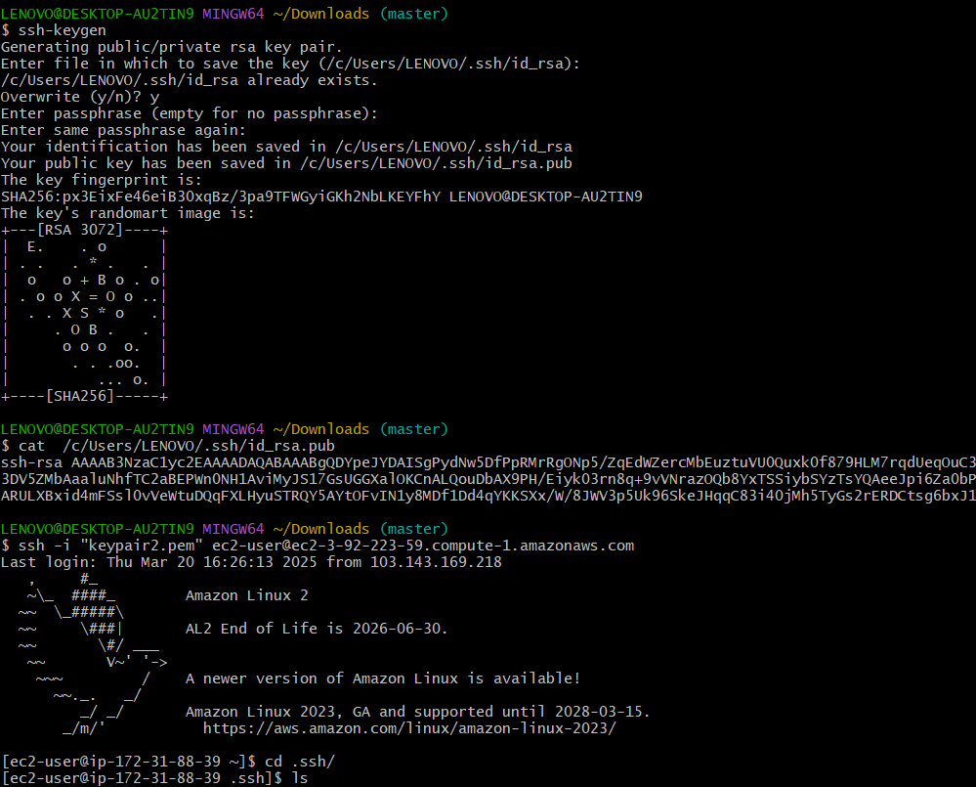

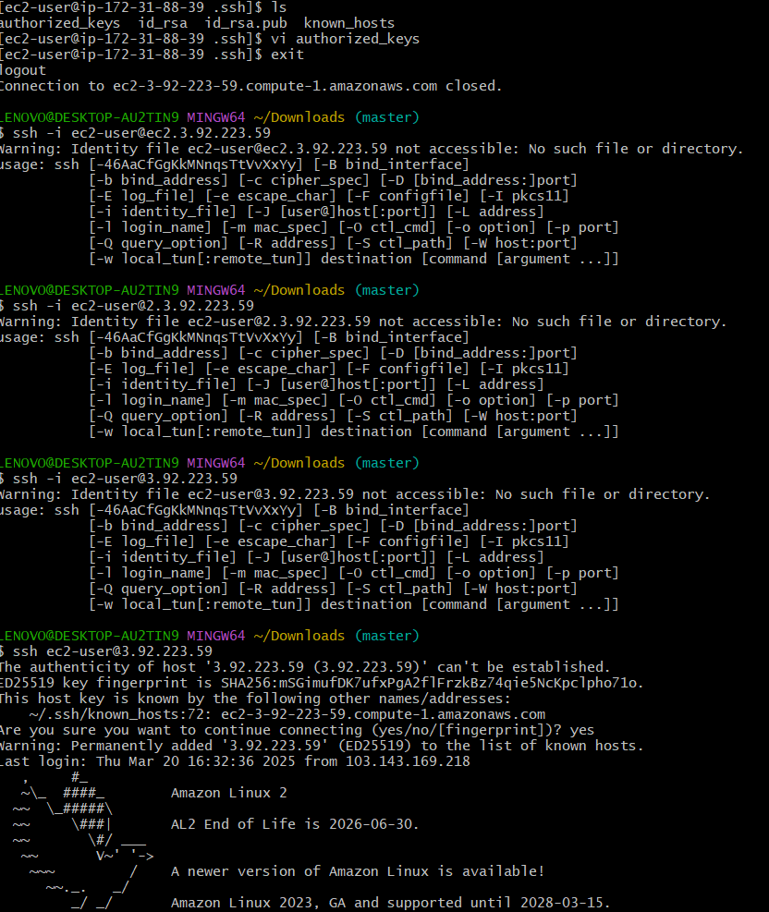

1. Launch any ec2 using spot purchasing option.

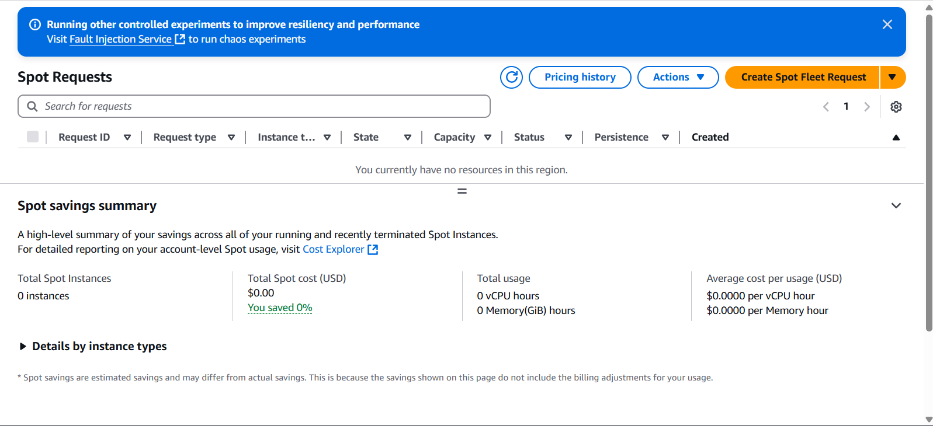

1. Enable Termination policy on ec2 created in Task 2.

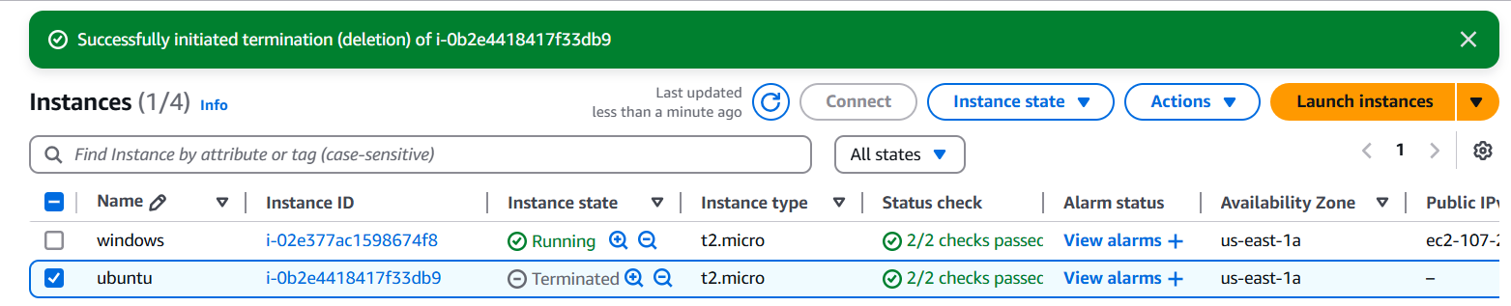

1. Launch one ec2 using Aws CLI.

We have to do create one ec2 instance

Aws configure and then give to accesskey and secreatekey

Go to security credential in our aws account and create access and security keys

Default region name

Aws run instance

aws ec2 run-instances --image-id ami-071226ecf16aa7d96 --count 1 --instance-type t2.micro --subnet-id subnet-0e3833d87308737c2

